Sensory Readable Help

Table of contents
Welcome to Readable 4
Readable Toolbar Buttons 5
Sensory Readable Toolbar View 7
Control Readable Speech 9
Select text & "underline-highlight" 10
Click Play Button 11
Press CTRL Key & Move Mouse 12
Stop Speech 14
Select a screen area with mouse 15
Create an MP3 audio file 16
Control MS Word text view 17
Change Font in MS Word 17
Spacing and Colour 18
Text Check & Lookup in MS Word 18
Spellcheck 19
Word Lookup 20
Thesaurus 22
Homophones 23
Show word pop-up 25
Word prediction support 26
Turn on word prediction 26
Turn on Autocorrect 27
Using Voice Typing with Readable 28
Extra Readable Tools 29
Sensory Tint 29
Sensory Ruler 32
Sensory PDF Reader 33
PDF Convert 33
Pronunciation Editor 33
Getting Help 35

Welcome to Readable
Welcome to Sensory Readable, software that enhances your computer experience by providing spoken feedback of the words under your mouse cursor. Sensory Readable is designed to assist users with reading difficulties, slow reading speeds or those who prefer to listen while interacting with their computer. Sensory Readable is also a great automatic proof-reader for your writing. By listening back to your written text, you can easily spot errors in content.

Sensory Readable uses advanced accessibility technology combined with professional text-to-speech capabilities to accurately identify and speak the words on your screen.
Sensory Readable is designed to provide "Point and Speak" capability to Microsoft Word, Edge browser, Notepad, Outlook and many more text software applications. It also introduces the synchronous Speak and Underline-Highlight method in these accessible applications, and more in the future.
Sensory Readable provides a great addition to Microsoft Word, and below you can see the Readable Toolbar (colour icon setting) when Microsoft Word is active.
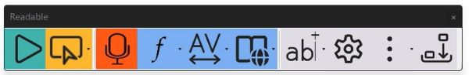
When you use Readable with other applications, the toolbar changes to show the active functions available. Below is the Sensory Readable Toolbar when in use with Microsoft Notepad with the toolbar in horizontal and vertical layouts
Readable Toolbar (horizontal) with Microsoft Notepad
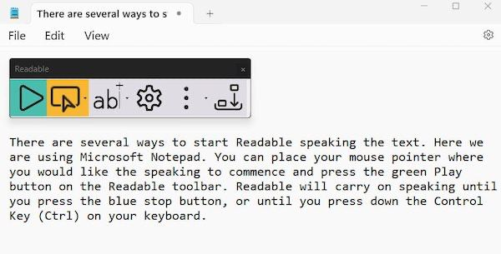.
Readable Toolbar (vertical) with Microsoft Notepad
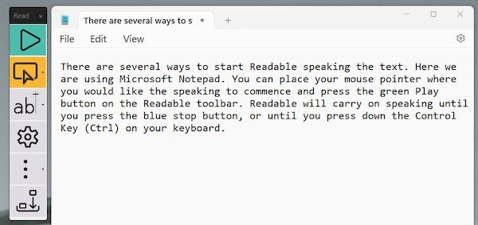

Readable Toolbar Buttons

Below is the Readable toolbar when Microsoft Word is the active window on your PC. Click each button on the toolbar below to go to the dedicated help section.

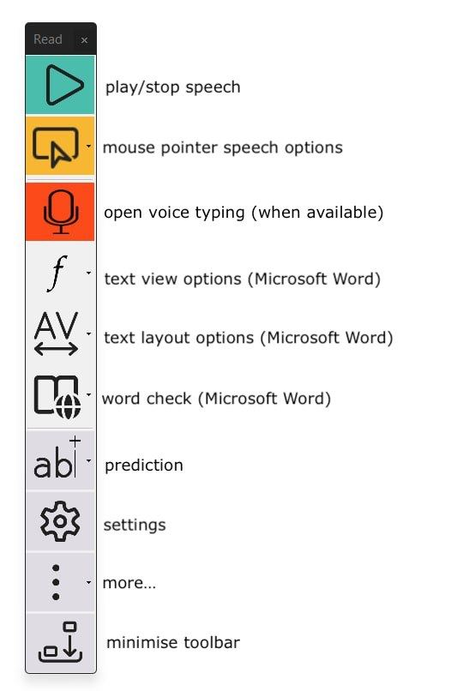

Sensory Readable Toolbar View
The Sensory Readable Toolbar operates very closely with your application window, for example Microsoft Word or Edge. The Toolbar view can be changed in View Settings, and the options are below.

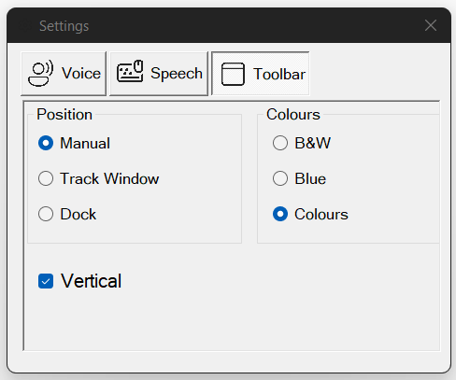

Colour Options for Toolbar in Manual Position with Microsoft Word (drag and move, minimise)

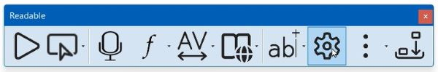

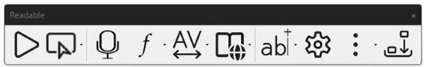

Colour Options for Toolbar in Manual Position with Edge, Notepad etc (drag and move, minimise)

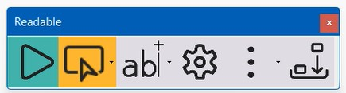

Vertical Toolbar in the "Docked" position, so fixed on the left hand side. Please note to close a docked window, minimise to the Windows dock and close with right click

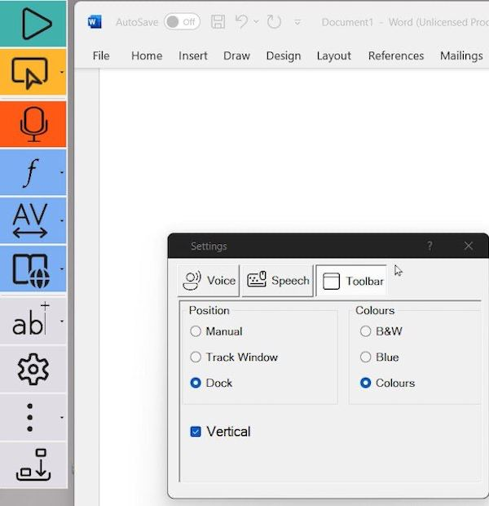

Horizontal Toolbar in the "Docked" position, so fixed on the left-hand side. Please note to close a docked window, minimise to the Windows dock and close with right click

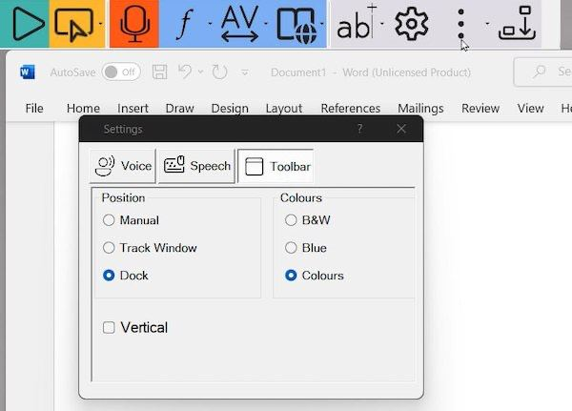

Please note to close a docked window, minimise to the Windows dock and close with right click

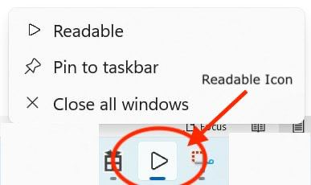

Control Readable Speech
The following speech control methods attempt to ensure you can access any text content on your PC with your mouse and listen to that text be spoken with the chosen text to speech voice.

- Select text with mouse cursor

- Click and Play method

- Point and Speak method (using Ctrl key and mouse)

- Select an area of the screen with the mouse cursor and use text extract

- Create an MP3 audio file from a document or selected text.

Different voices can be selected, as well as voice speed and volume in the Readable Settings. Readable integrates with a wide range of voices available installed on your PC. The voices you will see will depend on your Windows PC and also whether your version of Readable includes the premium Vocalizer voices pack for your country.

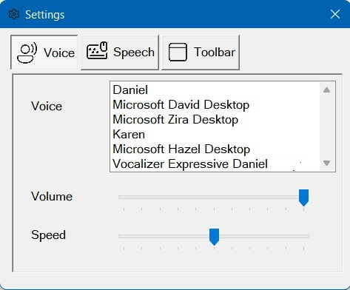

Select text & "underline-highlight"

Start Readable speaking selecting text with mouse.

You can also have any accessible text you select with your mouse to be spoken by Readable. This method can be turned off by removing the tick from the box by "Speak on Select" option in Speech Settings (see below). To stop the speech, press the stop icon on the Readable toolbar, press the Ctrl button on your keyboard of left click your mouse.

Readable can also underline highlight the current word being spoken in most Microsoft text applications (Word, Wordpad, TextEdit, Edge and more). You can change the colour of the highlight from the Speech settings.

Keyboard Echo

Readable can also speak as you type words with your physical keyboard, and you can select for Readable so speak after each character or each word. This setting is turned off by default and can be seen in the Speech Settings screen below.

Remove Highlighting

If you prefer minimal or no highlighting to show, we suggest you select a light gray or white highlight color.

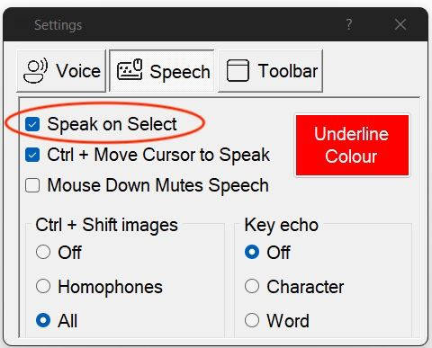

Click Play Button

Start Readable speaking with Play Button

You can place and click your mouse pointer/cursor where you would like the speaking to start and press the Play button on the Readable toolbar.

Readable will carry on speaking until you press the stop button, or until you press down the Control Key (Ctrl) on your keyboard.

Readable speaking with underline-highlight

Readable will also "Underline-Highlight" the spoken words in a colour you can choose. This applies to using Readable with Microsoft Word, Wordpad, Notepad, Edge Browser and other software we have tested. Readable can make Chrome Browser and many other non-Microsoft applications speak well, but they may not support Readable's "Underline-Highlight" method.

Press CTRL Key & Move Mouse

Start Readable speaking by pressing CTRL key and moving mouse

Readable will also start speaking the text “section” under your cursor, when you move your cursor pointer and "settle" on some text.

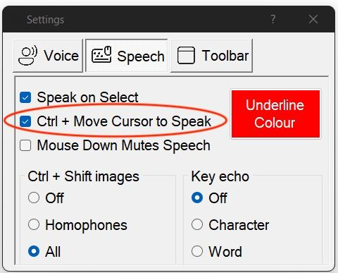

You can also choose for speaking to start when you press down the Control Button (Ctrl) and nudge (small movement) your mouse pointer. It will stop speaking when you press Ctrl. Select the "Ctrl+Move Cursor to Speak" setting to be on for this to operate. Remember when you press down Ctrl key speaking will only start when you nudge or move your mouse. It is easy to get the hang of this speech control method.

A text “section” can be set to always speak a word, a line, a block/paragraph or from the mouse cursor to the end of the document or article. To start speaking, press the Ctrl key and move the mouse cursor to the word where you would like “speaking” to start. Pressing Ctrl again will stop the speaking.

Reminder - if you land on a word and it doesn't immediately speak, just nudge your mouse pointer and it should then know that is where you want to speak from.

You will find that highly accessible Microsoft applications such as Word, Edge, Outlook, Notepad, Wordpad and more will allow Readable to underline-highlight and speak. Some applications may not support the under-line highlight at this point in time so will just speak the text content.

If the Ctrl & move mouse method does not start speech in the particular application you are working in, we would suggest you use the "select with mouse pointer and speak" method, or Text Extractor if available.

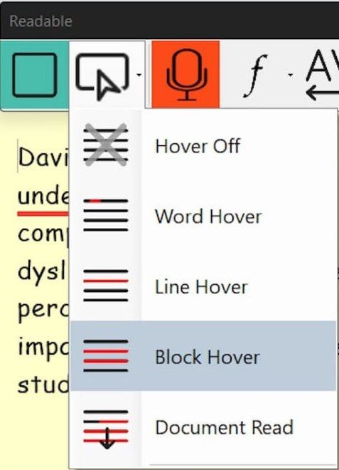

When you are using the Ctrl + move mouse cursor to speak, there are additional options for choosing the words spoken. The options can be seen on the image above.

- Hover Off - if you want to stop all speech when you move the mouse, click on the "Hover Off" setting

- Word Hover - If you struggle with some words, and don't require full sentences or blocks of text to be spoken, select Word Hover. Then the single word underneath the mouse will be spoken after pressing Ctrl and landing (or nudging) the mouse pointer on the word to be spoken.

- Line Hover - This setting will speak the whole line underneath the mouse, so useful for speaking lists.

- Block Hover - after pressing Ctrl and landing (or nudging) the mouse pointer within a "block" of text, the speech will start from the beginning of the block. Typically, a block would be a paragraph, but Readable makes a decision about what the block could be.

- Document Read - after pressing Ctrl and landing (or nudging) the mouse pointer within the written content on the screen, Readable will start speaking from that point in the "sentence/paragraph/block" and continue to the end of the text. It many applications that Underline-Highlight, then the document will also auto-scroll within the window. So this is a perfect setting for automated speaking starting from any word, continuing until stopped by Pressing Ctrl, pressing the Stop button on the Readable toolbar, or left clicking the mouse.

When Readable is speaking text in long formatted documents, such as Edge or Word, in the "Document Read" mode, you may find that a "mouse scroll wheel" or two fingered swipe on your laptop touchpad will skip speaking to the next paragraph or block. This is another way to move quicker through a document whilst listening to keep aspects of the text with Readable text to speech.

Stop Speech
If you are speaking text with Readable, there are a number of ways to stop the speech. They are:

- Press the Stop button on the Readable toolbar
- Press down the Ctrl key on your keyboard
- Left click your mouse (because Readable believes you want to move somewhere else on your PC or make an edit)

"Mouse Down Mutes Speech"

There is a setting to prevent the speech stopping when you left click your mouse. If you un-tick the "Mouse Down Mutes Speech" setting in the Speech Settings below, you will find that whilst Readable is speaking a longer text passage (e.g. a long web page) then you can use your mouse to move to a different app (side by side or on an extended monitor) to type some notes, review some e-mail or review other web feeds, or view accompany images etc. If you are on a single screen, we recommend changing your Underline Colour to be white/transparent.

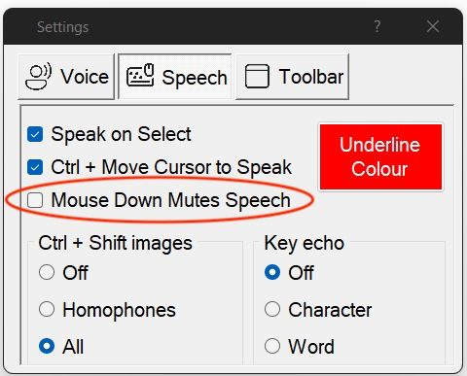

Select a screen area with mouse

Access any text for Readable to speak using Text Extractor.

Sometimes text on the screen is an image only or it isn’t accessible to Readable. Perhaps a photograph of an old document, scanned documents, inaccessible PDF files or certain applications.

It is easy to extract this text to the clipboard of your PC, by using the Readable Text Extractor tool. Click on Text Extractor, from within the yellow button menu pull-down, and a crosshair appears. Then select the area of your screen that contains the text you want to extract. This text will be recognised and quickly spoken. It can also be pasted from the clipboard to other applications as required.

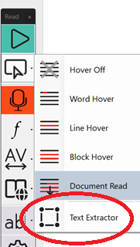

For the Text Extractor feature to be visible, your PC will require the free Microsoft PT dependency to be installed.

Create an MP3 audio file

Create MP3 audio files from text documents with Readable.

It may be helpful or productive to convert a whole text document to an MP3 audio file to listen to later, or transfer to your phone. Readable includes a Save to Audio file converter to convert text from Microsoft Word to .mp3.

Firstly, select and open the file (Word, Notepad, Wordpad) containing the text you would like to convert into MP3 audio. Then load Save to Audio converted from Readable and select the file location and create a file name to store the document. It will convert all the text contained in the document to the audio file.

You can also convert any text (for example from a web page) that you have selected and copied to your clipboard (select/copy). Then selected the Readable Save to Audio and the selected text will be saved.

To listen, find the MP3 file and open to listen, or transfer to your phone to play with your Music app.

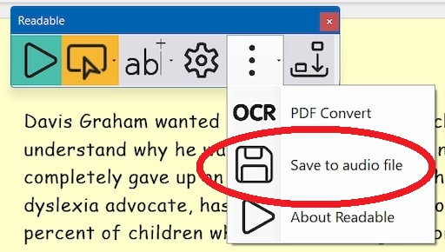

Control MS Word text view

Change Font in MS Word
When working in Microsoft Word with Readable, you can quickly change the view of how a Word document looks. With the font menu, you can quickly change the Font Size and choose from 3 popular easy to read font styles.

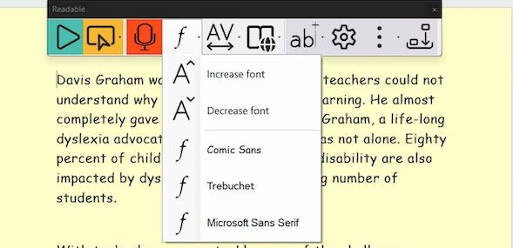

Spacing and Colour
When working in Microsoft Word with Readable, you can quickly change the view of how a Word document looks. With the "layout options" menu, you can quickly change the text spacing widths and choose a more suitable background colour for you Word document. This colour will come through when printing, so quickly change prior to printing if needed.

The Focus mode is a way to remove the menus and toolbars from the Microsoft Word document whilst reading, editing or proofreading.

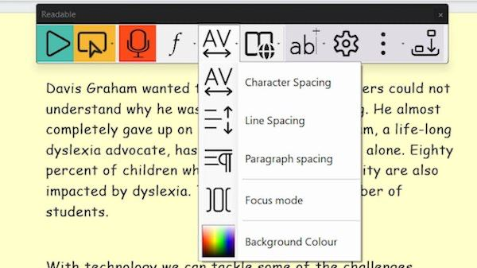.

Text Check & Lookup in MS Word
Sensory Readable works with Microsoft Word's powerful spelling, thesaurus, research tools. Sensory Readable adds speech to all these helpful word checking tools, as well as adding homophone detection and symbols.

The Readable word check menu item is shown below. This only appears when working in the Microsoft Word installed version on your PC.

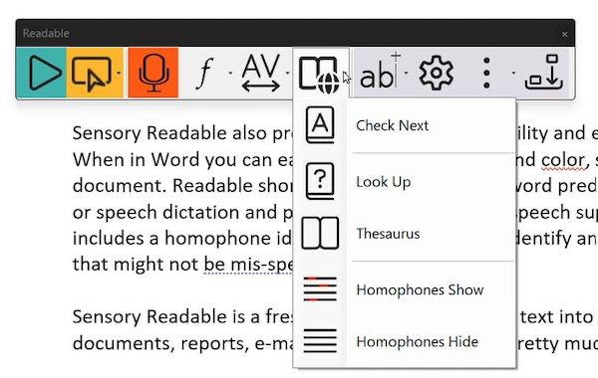

Spellcheck
Spell Check in Microsoft Word launched from Sensory Readable

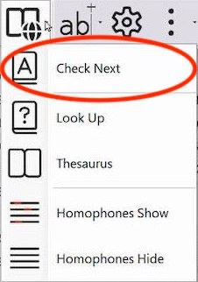

The Check Next function on Sensory Readable will work through the document and show any spelling queries (or spelling and grammar queries) in the right-hand Editor pane of Microsoft Word. If you move the cursor and press Ctrl Readable will instantly speak all suggestions and meanings information. You can make any spelling corrections from this classic Microsoft proofing tool.

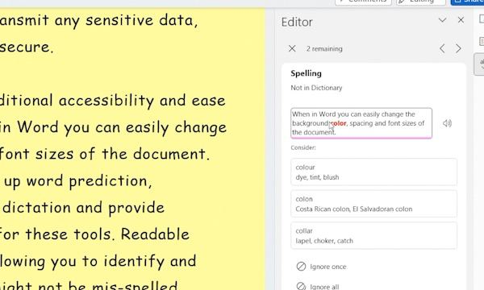

Word Lookup
It is possible to look up and research more information on a word or phrase, so typically look for definitions, examples or use, translations and origins. With Sensory Readable you can access this information from the Microsoft Word tools in two quick and easy ways, and Sensory Readable ensures it is fully accessible with text to speech and underline-highlighting.

The first method is to click your mouse pointer on the target word you would like to learn more about, and then Select the "LookUp" button on the Readable Word Check Menu.

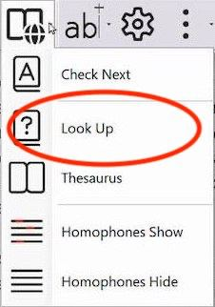

Microsoft Word will show the classic Research pane and the Search link for further information to be displayed.

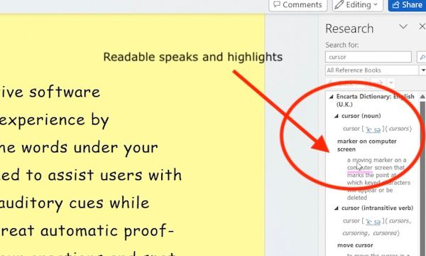

The second method to look up a word in the Look Up Dictionary or Thesaurus (when working in Microsoft Word) is to activate the word pop-up by pressing Ctrl & Shift key together, then move the mouse to the target word. You can see the links to Lookup and Thesaurus on the right of the pop up.

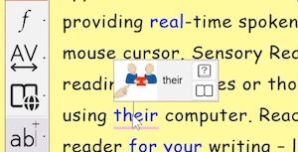

Thesaurus
When working with Microsoft Word, it is possible to look up a word in the Thesaurus, to provide alternatives (along with definitions etc). To do this you click your mouse cursor on the Word and select Thesaurus on the Readable toolbar.

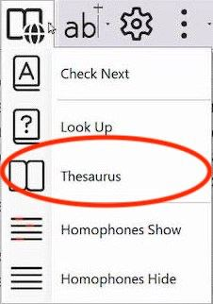

You can use Readable to speak and underline-highlight the Thesaurus, by pressing Ctrl and moving your mouse cursor to the target word.

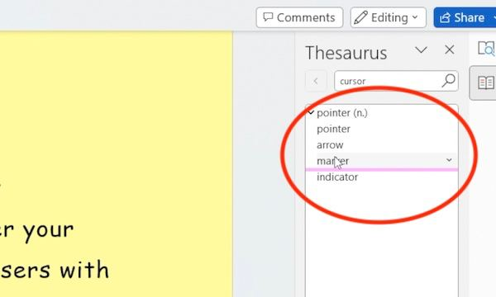

Homophones

Sensory Readable can identify many homophones (similar sounding words with differing spellings). This can be a useful tool for helping with proofreading. Click your mouse into the Microsoft Word document at the chosen start point. Then select "Homophones Show" from the word check menu item.

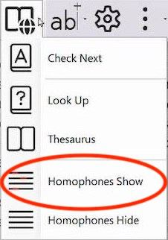

All the homophones will be changed to a blue colour. You can click on any word and LookUp the definition to check it is the one you need.

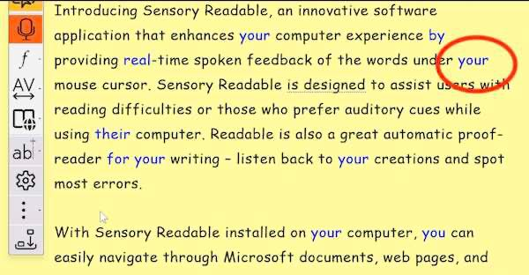

You can also check a word by pressing Ctrl & Shift key together. A homophone will often contain a symbol representing the word. The symbols can be turned off in the Settings.

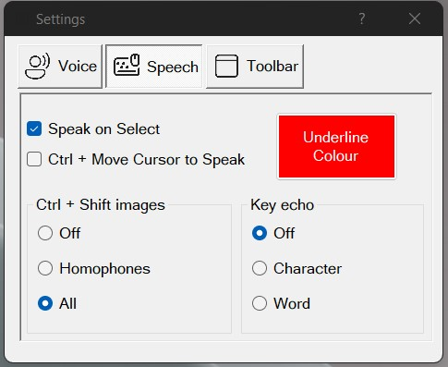

Show word pop-up

Press Ctrl & Shift to activate word pop-up

When using Sensory Readable in MS Word, pressing the Ctrl key & Shift key together, and then moving the mouse pointer to a word will activate the info popup. You might need to enable it first in the Readable Settings. If you have already ticked the "Ctrl+Move cursor to speak" then simply pressing the Shift key and moving the mouse pointer to the word, the info popup should appear.

Depending on the word, you will see the word syllable splits, you may see a Sensory symbol (especially if the word is a homophone) and the word will speak.

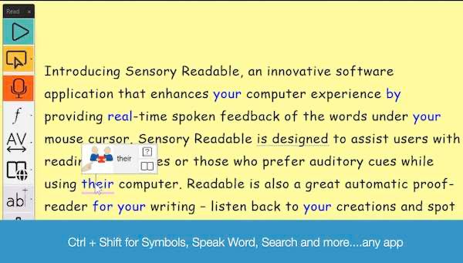

If you are working in Microsoft Word, you will also see link icons to the dictionary and thesaurus.

Word prediction support

Turn on word prediction
Text suggestions are useful throughout your writing process to improve your typing speed. It can help in many ways like if want to produce shorter and more effective texts, avoid grammatical mistakes and typos, and create a good flow of words and phrases. We are all familiar with this from using our phones.

Sensory Readable links to the Windows Text Suggestions to provide word prediction when using a physical keyboard. Readable will speak all the text suggestions in the floating suggestions bar, when you press Ctrl key and move the mouse over the words.

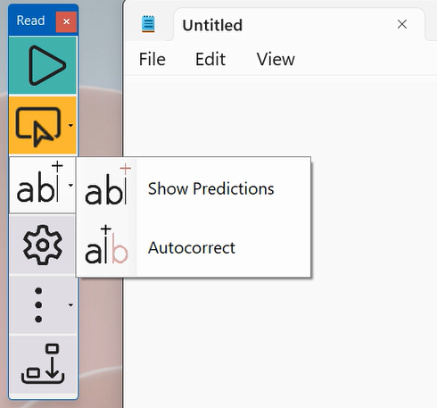

Turn on Autocorrect

When using the text predictions to help with typing, you can also auto-correct misspelled words as they are typed. This means that you can use auto-correct even while typing in Notepad, WordPad and other programs that don’t come with a built-in auto-correct feature. Readable will speak the suggested words, which might help is certain learning situations.

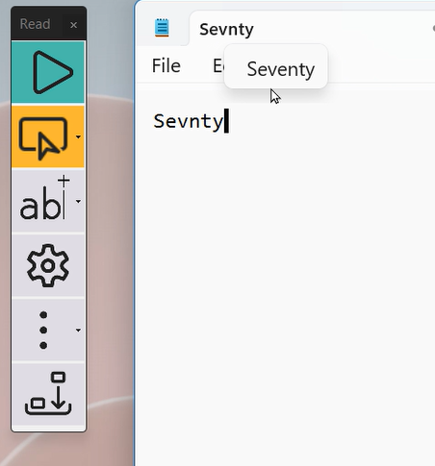

Using Voice Typing with Readable
Speech dictation or voice typing is a powerful way to write text because it doesn't make spelling mistakes. However, sometimes the speech recognition system doesn't quite hear what you said. Just like humans. It can also get the grammar wrong sometimes, but this is quickly improving with time.

With Sensory Readable I can now listen back to my dictated text to make sure it heard me correctly.

The Sensory Readable toolbar, when working with Microsoft Word allows you to easily enter speech dictation voice typing mode by click the Red Microphone button. Speech dictation mode requires your computer to have internet access.

Once you have finished dictating, you can listen back to the text using Readable, and spot any "speakos" or speech recognition errors that have been made. This will create confidence in using voice typing, when keyboard typing is slow, or spelling is a challenge.

Extra Readable Tools
With Sensory Readable, you may see some extra tools in the "three dots" pull down. These tools will have their own help files available.

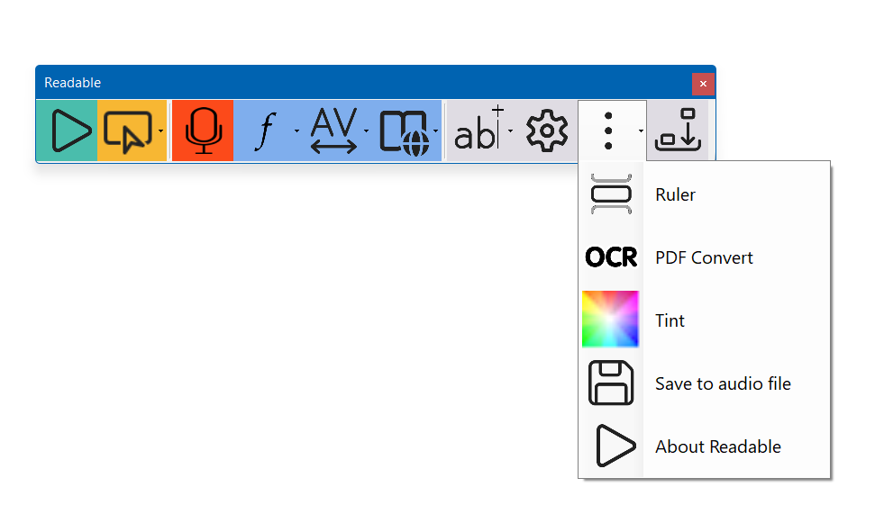

Sensory Tint
Overview
Welcome to Sensory Tint. Sensory Tint is a Windows accessibility application that tints your screen. You can choose any colour to suit your viewing situation. Sensory Tint will tint extended or dual displays.

It is a simple app to setup and can be minimised to the dock when being used.

Choose the colour of the screen tint that you prefer. The screen will stay tinted until Sensory Tint is closed.

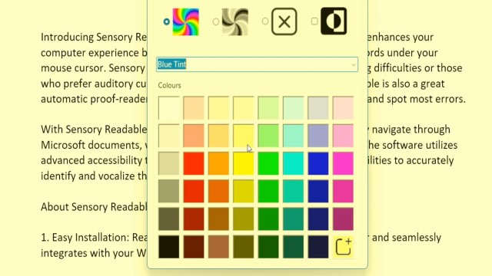

The 4 options for colour tinting are Full Colour, Mono, None and Inverted

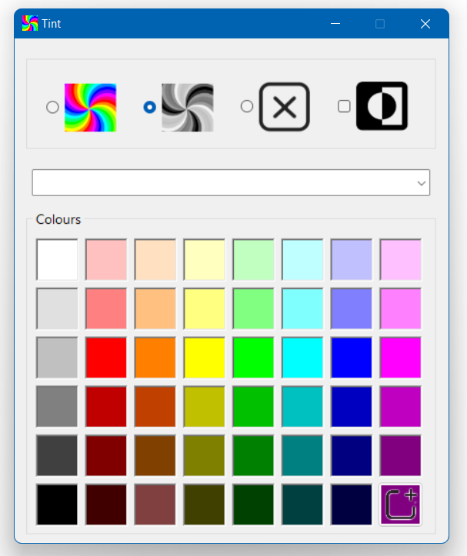

In addition to the colour palette available, there is a pull-down list of preset tints and effects that could be selected. This pull down list includes some adjustments to colours (not a tint) that may assist with colour vision deficiency.

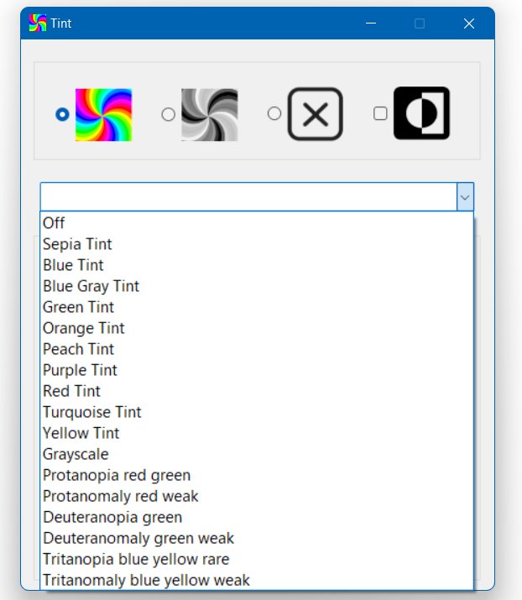

You can adjust the colour palette to add custom colours if preferred.

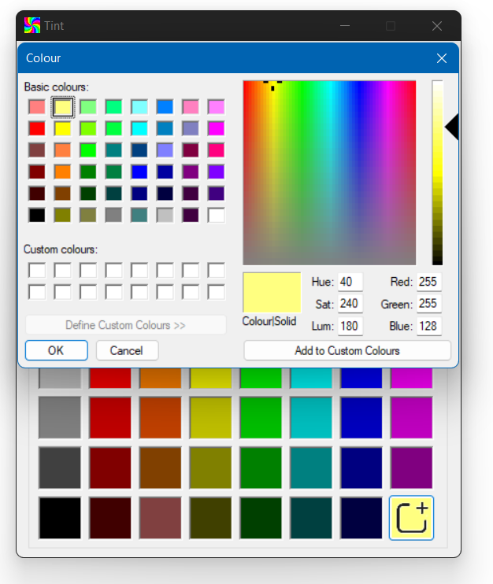

Sensory Ruler
Sensory Ruler is a screen reading ruler, tinted software overlay, providing a flexible variable sized reading ruler. Colours and size of the ruler can be set from defaults to custom colours. Above and below the Ruler can be set with a different colour to contrast. Great to help with focus on lines or section of text.

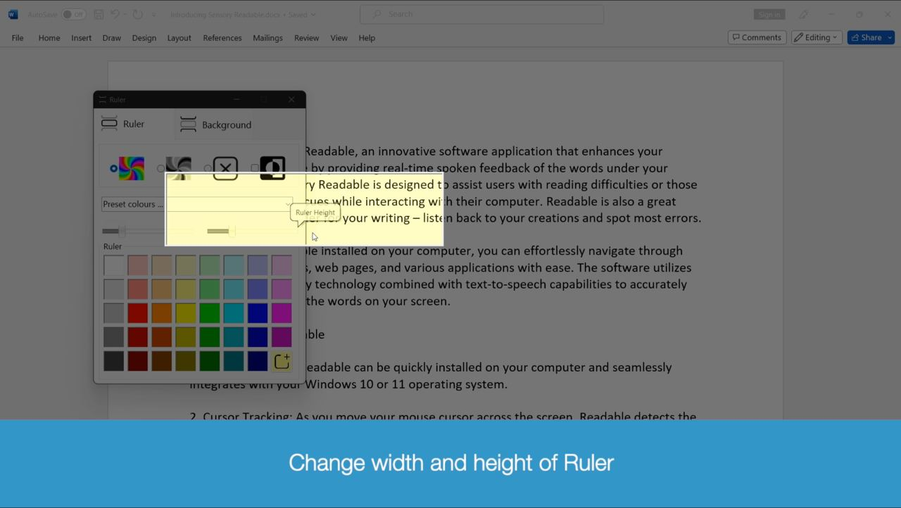

Sensory PDF Reader

Sensory PDF Reader is an accessible PDF viewer with built in speech. In can also be used as a computer reader for examinations.

Browse the full help file for Sensory PDF Reader here.

PDF Convert
PDF Convert will convert scanned images of text documents, or photographs of text, into accessible versions. PDF Convert extracts the text using optical character recognition (OCR) but the document image looks identical. Therefore, the converted document is now accessible and can be spoken with text to speech such as Readable PDF or Readable for Windows and also copied and pasted.

Browse the help file information for PDF Convert here.

Pronunciation Editor
Readable Editor

Readable includes a separate installed tool called Readable Editor. You can run this tool by searching for Readable in the Windows Search box and it will appear.

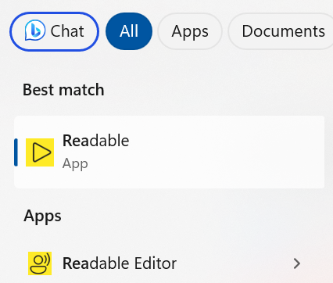

When you run the Readable Editor, it will show a Pronunciation Editor. We find that most recent text to speech voices are highly accurate in their pronunciations. However, sometimes they can struggle with certain personal names, company names and abbreviations. The pronunciation editor can be used to "adjust" how a voice might handle a tricky to pronounce name, or turn long phrases into abbreviations (e.g. National Health Service to NHS).

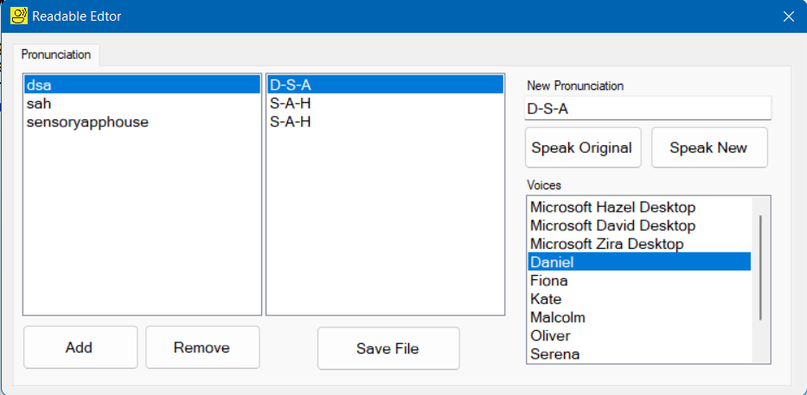

When you have added a new pronunciation or abbreviation, press "Save File" and the list will be updated. Next time you restart Readable, it will load the new pronunciation list.

Getting Help
To get further help, contact us by email at support@sensoryapphouse.com or visit www.sensoryreadable.com

